# Best Programming Practice

1. All values as variables including Fixed, User Inputs, and Results
2. Avoid Hard Coding of variables wherever possible
3. Proper naming conventions for all variables

String name = "Eric";

double height = input.nextDouble();

double totalDistance = distanceFromToVia + distanceViaToFinalCity;

1. Proper Program Name and Class Name
2. Follow proper indentation
3. **Sample Program 1 -** Write a program to display Sam with Roll Number 1, Percent Marks 99.99, and the result ‘P’ indicates Pass(‘P’) or Fail (‘F’).

IMP => Follow Good Programming Practice demonstrated below in all Practice Programs

// Creating Class with name DisplayResult indicating the purpose is to display

// result. Notice the class name is a Noun.

class DisplayResult {

public static void main(String[] args) {

// Create a string variable name and assign value Sam

String name = "Sam";

// Create a int variable rollNumber and assign value 1

int rollNumber = 1;

// Create a double variable percentMarks and assign value 99.99

double percentMarks = 99.99;

// Create a char variable result and assign value 'P' for pass

char result = 'P';

// Display the result

System.out.println("Displaying Result:\n" +name+ " with Roll Number " +

rollNumber+ " has Scored " +percentMarks+

"% Marks and Result is " +result);

}

}

1. **Sample Program 2 -** Eric Travels from Chennai to Bangalore via Vellore. From Chennai to Vellore distance is 156.6 km and the time taken is 4 Hours and 4 Mins and from Vellore to Bangalore is 211.8 km and will take 4 Hours and 25 Mins. Compute the total distance and total time from Chennai to Bangalore

// Create TravelComputation Class to compute the Distance and Travel Time

class TravelComputation {

public static void main(String[] args) {

// Create a variable name to indicate the person traveling

String name = "Eric";

// Create a variable fromCity, viaCity and toCity to indicate the city

// from city, via city and to city the person is travelling

String fromCity = "Chennai", viaCity = "Velore", toCity = "Bangalore";

// Create a variable distanceFromToVia to indicate the distance

// between the fromCity to viaCity

double distanceFromToVia = 156.6;

// Create a variable timeFromToVia to indicate the time taken to

// travel from fromCity to viaCity in minutes

int timeFromToVia = 4 * 60 + 4;

// Create a variable distanceViaToFinalCity to indicate the distance

// between the viaCity to toCity

double distanceViaToFinalCity = 211.8;

// Create a variable timeViaToFinalCity to indicate the time taken to

// travel from viaCity to toCity in minutes

int timeViaToFinalCity = 4 * 60 + 25;

// Create a variable totalDistance to indicate the total distance

// between the fromCity to toCity

double totalDistance = distanceFromToVia + distanceViaToFinalCity;

// Create a variable totalTime to indicate the total time taken to

// travel from fromCity to toCity in minutes

int totalTime = timeFromToVia + timeViaToFinalCity;

// Print the travel details

System.out.println("The Total Distance travelled by " + name + " from " +

fromCity + " to " + toCity + " via " + viaCity +

" is " + totalDistance + " km and " +

"the Total Time taken is " + totalTime + " minutes");

}

}

# Level 1 Practice Programs

1. Write a program to find the age of Harry if the birth year is 2000. Assume the Current Year is 2024

I/P => NONE

O/P => Harry's age in 2024 is ___

**CODE** **OUTPUT**

1. Sam’s mark in Maths is 94, Physics is 95 and Chemistry is 96 out of 100. Find the average percent mark in PCM

I/P => NONE

O/P => Sam’s average mark in PCM is ___

**CODE OUTPUT**

1. Create a program to convert the distance of 10.8 kilometers to miles.

Hint: 1 km = 1.6 miles

I/P => NONE

O/P => The distance ___ km in miles is ___

**CODE** **OUTPUT**

1. Create a program to calculate the profit and loss in number and percentage based on the cost price of INR 129 and the selling price of INR 191.

**Hint =>**

1. Use a single print statement to display multiline text and variables.
2. Profit = selling price - cost price
3. Profit Percentage = profit / cost price * 100

**I/P =>** NONE

**O/P =>**

The Cost Price is INR ___ and Selling Price is INR ___

The Profit is INR ___ and the Profit Percentage is ___

**CODE OUTPUT**

1. Suppose you have to divide 14 pens among 3 students equally. Write a program to find how many pens each student will get if the pens must be divided equally. Also, find the remaining non-distributed pens.

**Hint =>**

1. Use Modulus Operator (%) to find the reminder.
2. Use Division Operator to find the Quantity of pens

**I/P =>** NONE

**O/P =>** The Pen Per Student is ___ and the remaining pen not distributed is ___

**CODE OUTPUT**

1. The University is charging the student a fee of INR 125000 for the course. The University is willing to offer a discount of 10%. Write a program to find the discounted amount and discounted price the student will pay for the course.

**Hint =>**

1. Create a variable named fee and assign 125000 to it.
2. Create another variable discountPercent and assign 10 to it.
3. Compute discount and assign it to the discount variable.
4. Compute and print the fee you have to pay by subtracting the discount from the fee.

**O/P =>** The discount amount is INR ___ and final discounted fee is INR ___

**CODE OUTPUT**

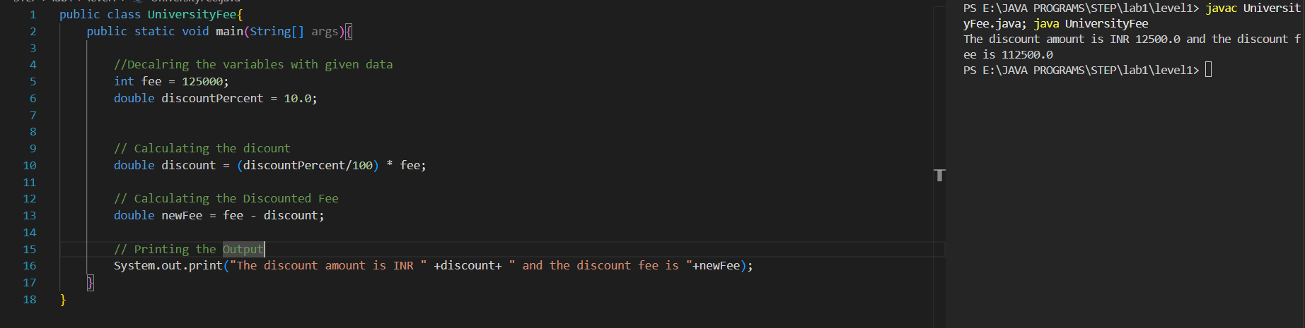

1. Write a Program to compute the volume of Earth in km^3 and miles^3

**Hint =>** Volume of a Sphere is (4/3) * pi * r^3 and radius of earth is 6378 km

**O/P =>** The volume of earth in cubic kilometers is ____ and cubic miles is ____

**CODE OUTPUT**

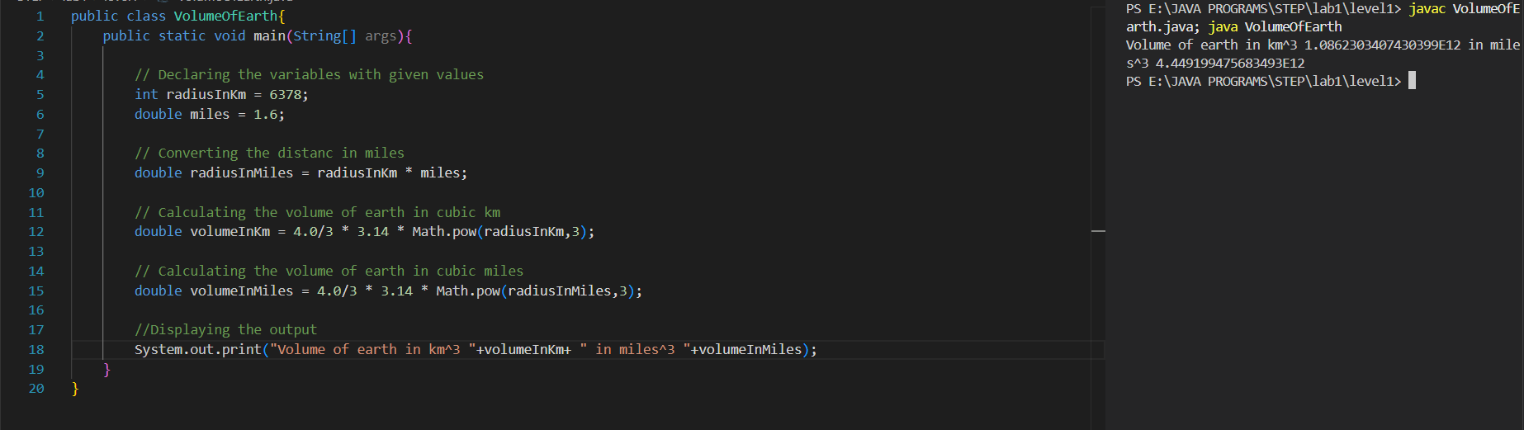

1. Create a program to convert distance in kilometers to miles.

**Hint =>**

1. Create a variable km and assign type as double as in double km;
2. Create Scanner Object to take user input from Standard Input that is the Keyboard as in Scanner input = new Scanner(System.in);
3. Use Scanner Object to take user input for km as in km = input.nextInt();
4. Use 1 mile = 1.6 km formulae to calculate miles and show the output

**I/P =>** km

**O/P =>** The total miles is ___ mile for the given ___ km

**CODE OUTPUT**

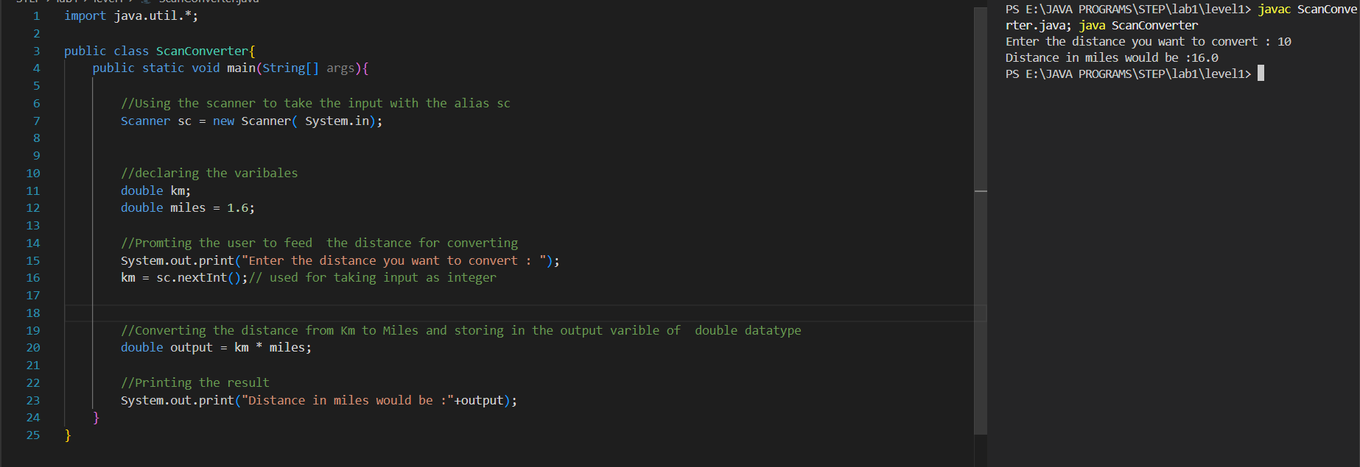

1. Write a new program similar to the program # 6 but take user input for Student Fee and University Discount

**Hint =>**

1. Create a variable named fee and take user input for fee.
2. Create another variable discountPercent and take user input.
3. Compute the discount and assign it to the discount variable.
4. Compute and print the fee you have to pay by subtracting the discount from the fee.

**I/P =>** fee, discountPrecent

**O/P =>** The discount amount is INR ___ and final discounted fee is INR ___

**CODE OUTPUT**

1. Write a program that takes your height in centimeters and converts it into feet and inches

**Hint =>** 1 foot = 12 inches and 1 inch = 2.54 cm

**I/P =>** height

**O/P =>** Your Height in cm is ___ while in feet is ___ and inches is ___

**CODE OUTPUT**

